1. **You can talk to application using API or CLI. Application can be GitHub, Jenkins or Kubernetes etc.**
2. **API stands for Application interface.**
3. **As a DevOps engineer you maintain multiple GitHub repositories. You have to make sure necessary access has been given to respective team.**
4. **Creating new organization in github is like creating a new company.**
5. **How to generate API token in Github?**

**Login > settings > Developer Settings > Generate New Token (Classic)**

1. **Exporting Github username/token in bash. So you can use it as a variable in script.**



1. **Script to list of users in Github.**

[**https://github.com/iam-veeramalla/shell-scripting-projects/blob/main/github-api/list-users.sh**](https://github.com/iam-veeramalla/shell-scripting-projects/blob/main/github-api/list-users.sh)

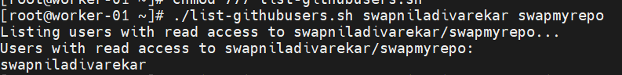

1. **Task: Add helper function in above script for user who do not know how to run the script with proper arguments.**